

Welcome to MyFooballClub Registration at Scots Football Club

Go to www.myfootballclub.com.au

- Select 'Register Now'
& wait for new screen.
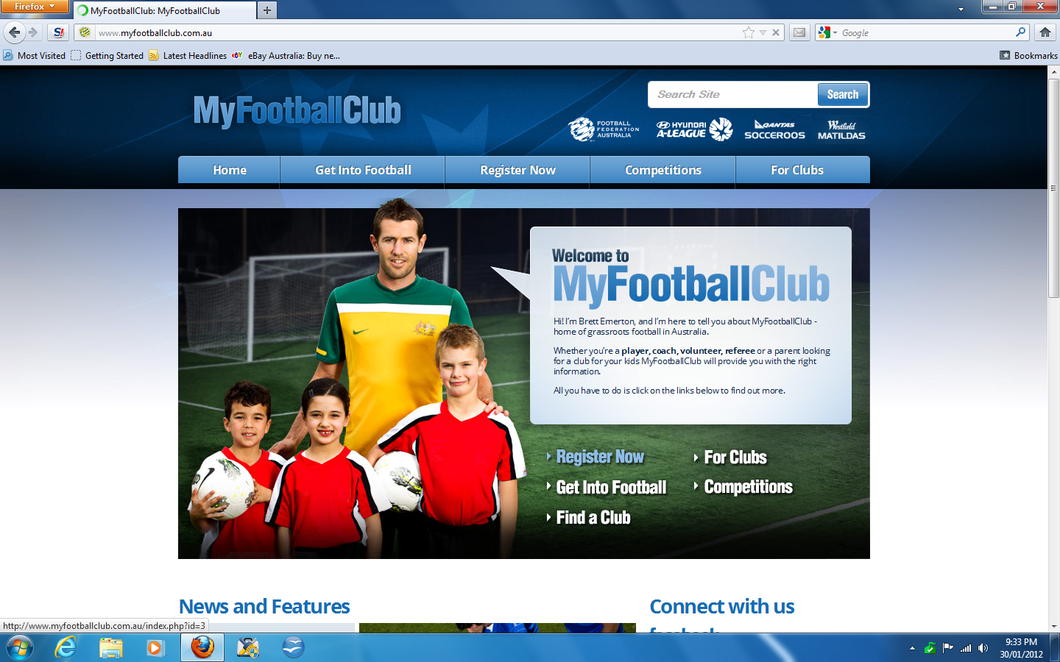
- Select 'Player Registration'
& wait for new screen.
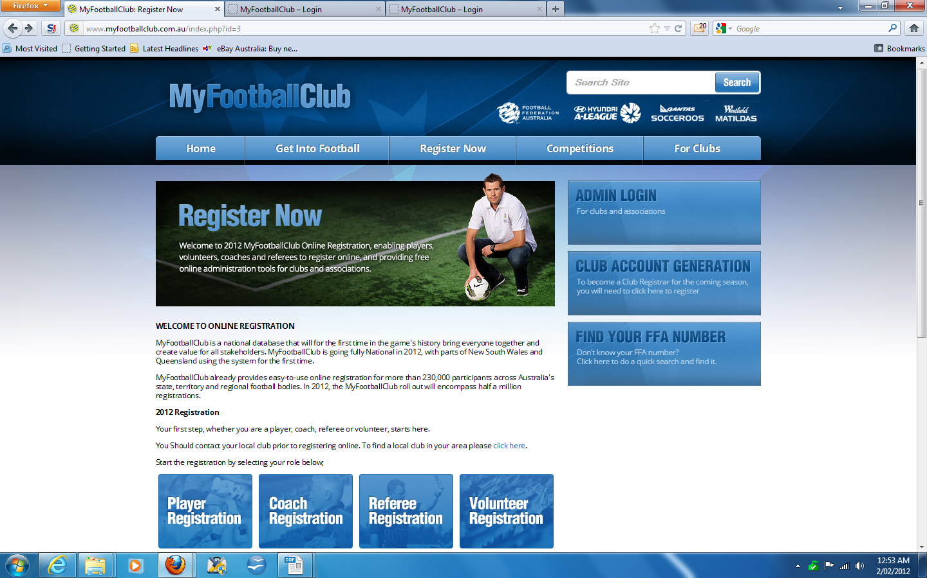
- Select '
I know my FFA number and I am ready to proceed to a login screen to retrieve my password and or complete my registration.
Click here to to proceed to the login pages '
& wait for new window.
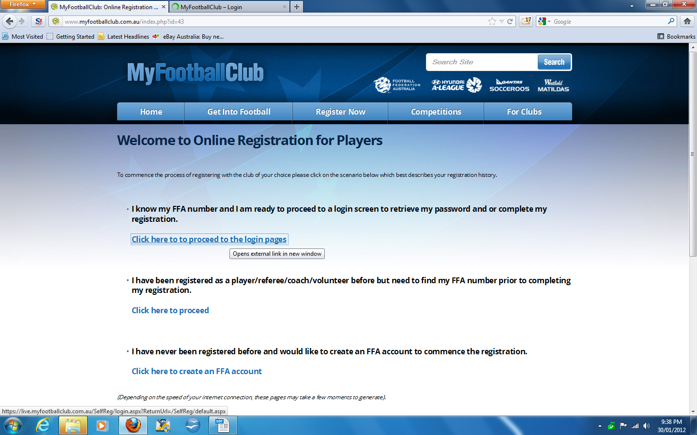

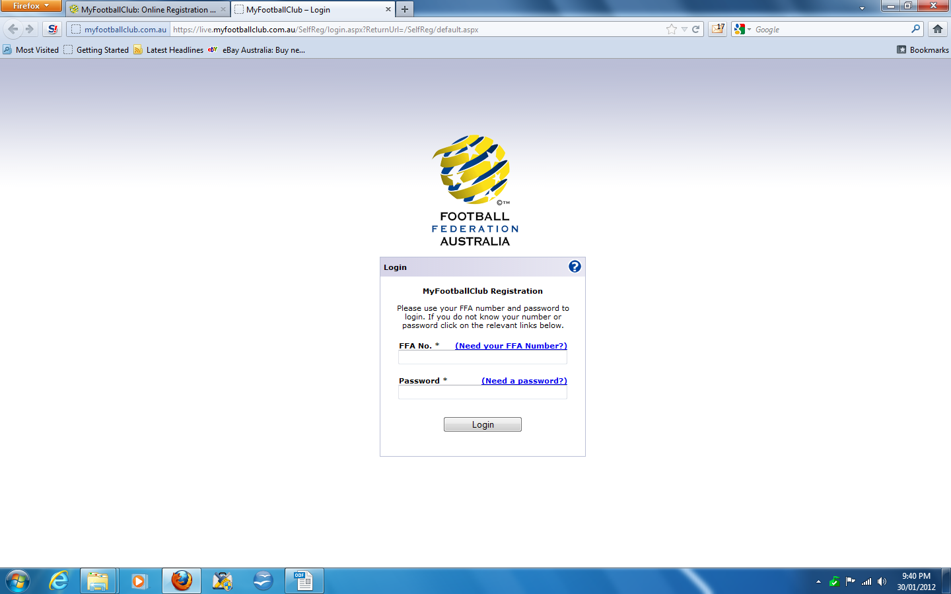
4. Enter FFA Number & Password (Provided by Club Official OR follow reset procedure at bottom)

Selecting Our Club
- When you log in for the first time click “Registration Now” in the members window.
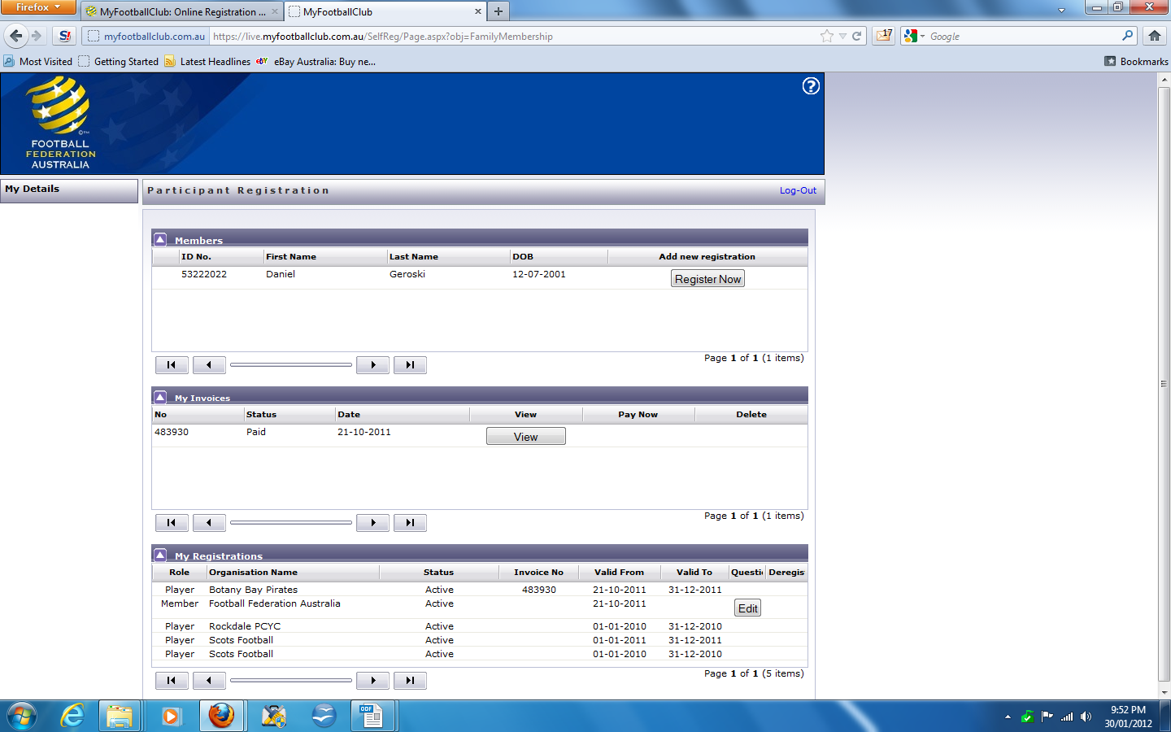
- View and update your contact details (if necessary)
- Upload photo (required)
- Click 'Proceed with registration' button on bottom of screen.
& wait for popup window

- Type in our Club name which is <Scots Football Club>.
- Under Select Role: choose “Player”.
- Select Level <Enter Club Package>. Our Club Package for this level is <Insert Cost>.
- Click Add.
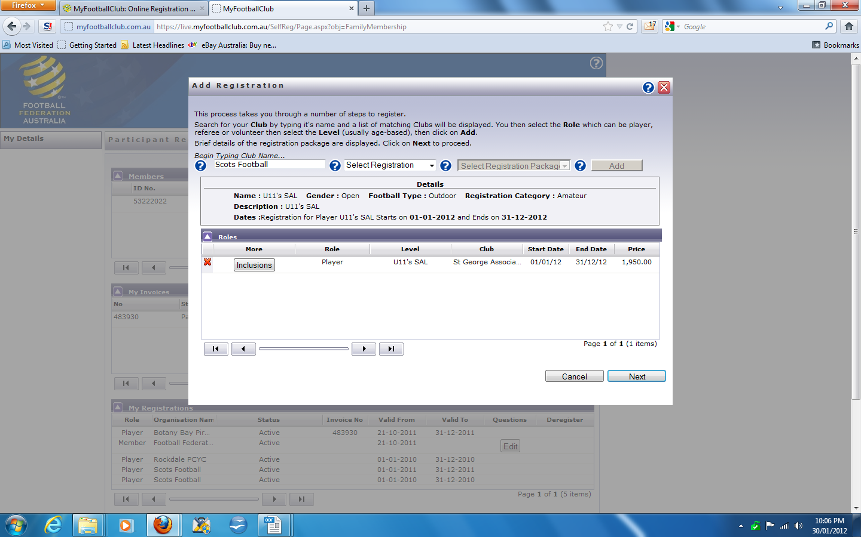
- Click Next.

Acknowledging Terms and Conditions
- Read and Acknowledge all Terms and Conditions and Click Next.

Payment Options Screen
- You will be given the option to <Pay Now> or <Invoice Me>.
- You will be sent an invoice via email, whether you pay online or not.

You will have the Opportunity to Purchase additional items
- <Club to add what is on offer if applicable>

Answer Additional Questions
- Save All Answers and Click Next.

Your Registration is Now Complete
- You are now pending awaiting approval or pending awaiting payment. The Club Registrar will now complete the final step of accepting your registration. We will contact you directly to advise the next steps.

Where do I go for help?
- FAQ’s on the website.
- Player resources (Videos/Manuals) which are under the resources section in 2010 Registration.
- Call FFA Call Centre on (02) 8020 4199 or myfootballclub@footballaustralia.com.au particularly if you are having problems finding yourself or retrieving your password because your email is not matching.

Retrieving a Password/Creating an Account
- Select “2011 Registration”
- Select “2011 Player Registration” on the right side of the page.
- You will be given two options which will allow you to find your FFA number, retrieve a password and enter the system.
  - If you can find your number, click on your name and proceed to the login screen. You will need to generate a password using your email address.
    - If your email address does not match with data in MyFootballClub – Contact FFA support on (02) 8020 4199 or myfootballclub@footballaustralia.com.au to update your email and log into the system.
  - If you can’t find your FFA number- Don’t Panic! Follow the links to creating a new account. Or follow this link here: https://live.myfootballclub.com.au/Signup/FFAMemberSignup.aspx?StartAt=Waivers
  - This will allow you to generate a new number and password. These details will be emailed to you immediately and you will be able to login from there.

